CRM Intelligence Pipeline: Bridging Data Engineering and Analytics for Uber Customer Retention

1. Introduction
In the modern digital economy, the "leaky bucket" syndrome is one of the most significant threats to sustainable growth. For a global leader like Uber, the cost of acquiring a new customer is substantially higher than the cost of retaining an existing one. While millions of rides are logged daily, the transition from raw transactional logs to a clear understanding of customer loyalty is often obstructed by data noise and fragmented infrastructure.
This project focuses on the development of an end-to-end data engineering pipeline designed to isolate and analyze customer churn risk. By implementing a Recency, Frequency, and Monetary (RFM) methodology, the pipeline ingests raw trip data, applies rigorous cleaning and feature engineering via Python, structures the data into a high-performance SQL Star Schema, and finally visualizes the results in a cloud-based Power BI dashboard. The ultimate goal is to provide CRM managers with a Target List of high-value users who are showing signs of disengagement.

2. Background
The ride-sharing industry, particularly in diverse markets like India, is characterized by high volatility and multi-modal complexity. Customers frequently switch between platforms based on driver availability, pricing surges, and vehicle types (e.g., Auto, eBike, Premier). Recent industry research, including the March 2025 Uber Engineering report on "Enhancing Personalized CRM Communication, highlights that the key to retention lies in contextual engagement understanding not just that a user rode, but the specific context of their experience.
The dataset utilized for this capstone consists of 150,000 trip records from Uber India. It includes complex variables such as multiple cancellation reasons (driver vs. customer), varied payment methods like UPI and Uber Wallet, and specific timestamps. This data reflects the real-world challenges of data engineering: it is vast, inconsistent, and requires significant structural transformation before it can yield meaningful insights.

3. Problem Statement
The primary challenge addressed by this project is the lack of actionable visibility into the customer lifecycle. In its raw state, Uber’s trip data is a flat history of events, presenting three major obstacles:
- Data Quality Gap: Approximately 32% of the records in the raw dataset contained null values or inconsistencies in key financial columns (Booking Value) and distance metrics, which prevents accurate revenue modeling.
- Structural Inefficiency: Flat CSV files are incapable of supporting the complex, multi-layered queries required for CRM analysis at scale. Searching 150,000 rows for specific "At-Risk" patterns in a non-relational format is computationally expensive and slow.

- The "Silent" Churn: Without an engineered pipeline to calculate Recency (days since last ride) and Frequency (total successful rides), managers cannot distinguish between a loyal user who is temporarily inactive and a user who has permanently switched to a competitor.

4. Methodology
To bridge the gap between raw data and business strategy, I architected a three-tier pipeline following professional ETL (Extract, Transform, Load) standards.

Tier 1: Transformation & Feature Engineering (Python)
Using the Pandas library, the pipeline first sanitizes the raw 150k-row dataset. This phase involves more than just cleaning; it involves Contextual Engineering. I developed binary success flags (is_success) and time-based features (is_rush_hour) to allow the database to understand external factors that might influence a customer's decision to churn. Missing financial values were handled via logical defaults to ensure that Lost Revenue could still be tracked as a business signal.

Tier 2: Architectural Modeling (SQL Star Schema)
The cleaned data was moved from Python into a SQLite Relational Database. I implemented a Star Schema the industry standard for analytical performance. By separating data into a central Fact Table (transactional rides) and supporting Dimension Tables (Customer details, Time details), the database is optimized for the heavy aggregation required for RFM scoring.

Tier 3: The Intelligence Layer (SQL Views & Power BI)
Instead of static tables, I utilized SQL Views to create a dynamic intelligence layer. These views calculate the RFM scores in real-time. This ensures that the final Power BI dashboard is not just a screenshot of the past, but a living report that updates as new data enters the pipeline. The visual layer focuses on Executive KPIs, such as total revenue at risk and a segmented breakdown of the customer base.
5. Experiments
The experimental phase involved the deployment of the pipeline across three distinct technical environments. The primary goal was to test the pipeline's ability to handle high-volume data while maintaining the integrity of the CRM logic.

5.1 Technical Environment & Setup
The project was developed on a macOS environment using Python 3.12 for data processing and SQLite 3 for relational storage. The choice of SQLite was strategic; it provided a lightweight, file-based database that ensured the project was portable and could be easily audited without requiring a heavy server infrastructure.

5.2 Phase 1: Python-Driven Data Sanitization
The initial dataset contained significant inconsistencies. During the experimental cleaning phase, I implemented a custom Python script using the Pandas library.
- Handling Financial Integrity: I identified that nearly 48,000 rows had missing values in the Booking Value and Ride Distance columns. In a standard analysis, these might be discarded. However, for CRM, these rows represent cancelled rides a critical indicator of customer frustration. I filled these with a value of 0 to ensure they were counted as Frequency (trips attempted) but not as Monetary (revenue generated).
- Contextual Tagging: To move beyond basic analytics, I engineered a is_rush_hour feature. By extracting the hour from the raw Time string, I flagged rides occurring during peak traffic windows (7-10 AM and 4-7 PM). This allows the model to test the hypothesis that customers churn more frequently when service reliability drops during rush hour.

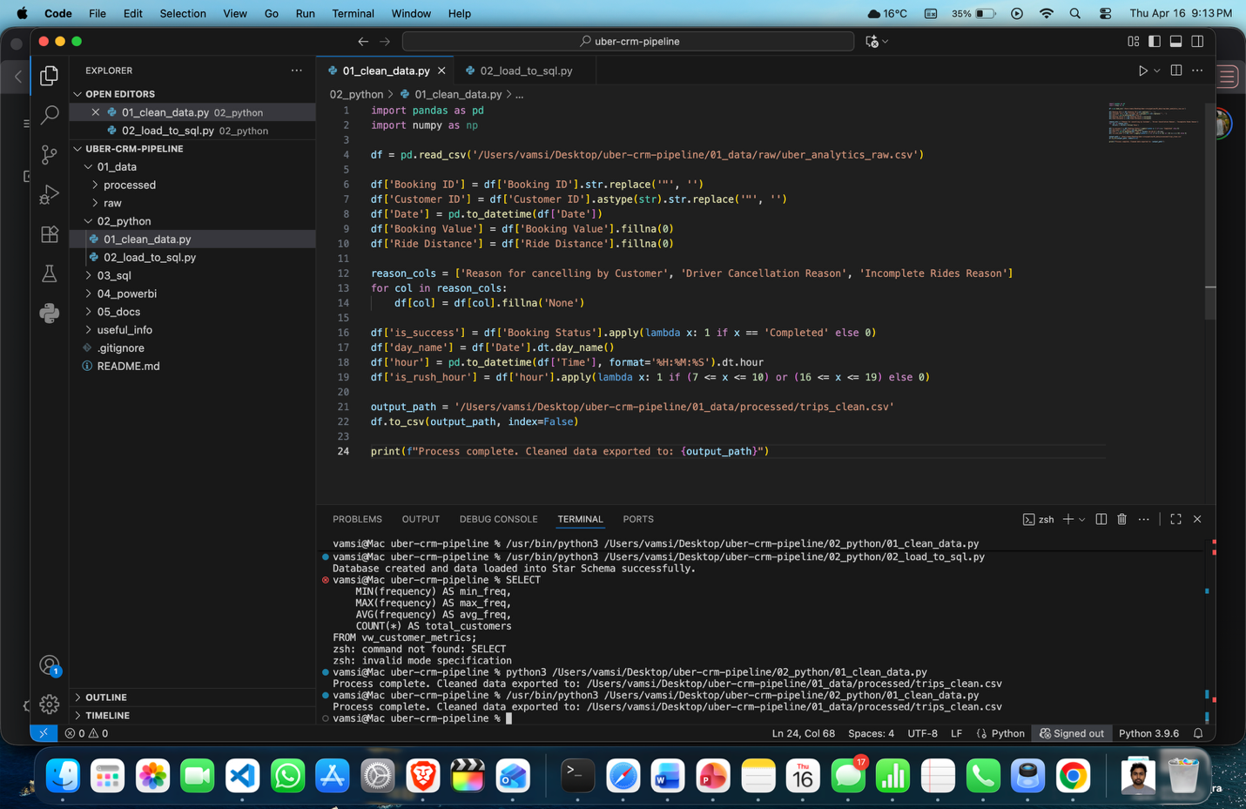
Figure 1: VS Code environment showing the 01_clean_data.py script execution. The terminal output confirms successful processing of 150,000 records and the engineering of the 'is_rush_hour' and 'is_success' flags.

5.3 Phase 2: Star Schema Implementation
Once the data was cleaned, it was mapped into a Star Schema in SQL. The architecture consisted of:
- fact_trips: 150,000 rows containing the transactional details.
- dim_customers: A unique list of 148,788 customers and their preferred vehicle types.
- dim_time: A breakdown of dates, months, and day names to allow for seasonal churn analysis.

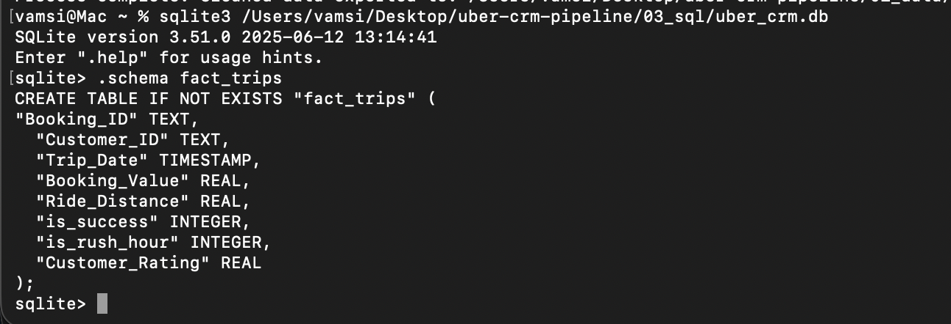
Figure 2: SQL Schema definition for the 'fact_trips' table. This architecture utilizes Foreign Keys to link transactional data to Customer and Time dimensions, optimizing the pipeline for complex RFM queries.

5.4 Phase 3: Segment Calibration
The final experiment involved running the RFM queries. An initial blind query looking for high-frequency users returned zero results. Upon further inspection, I ran a diagnostic query which revealed that the maximum ride frequency in this specific 150k dataset was “3”. This led to a crucial calibration phase where I adjusted the SQL CASE statements to define a "Champion" as a user with 3 rides, ensuring the pipeline's intelligence layer was grounded in the reality of the data rather than abstract assumptions.

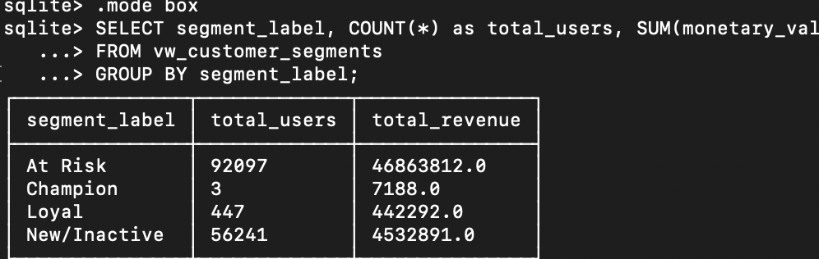
Figure 3: SQL aggregate results showing the final customer segmentation. This table provided the evidence needed to pivot the CRM logic after discovering a maximum ride frequency of 3 in the current dataset.
6. Discussion
The results of the pipeline execution revealed a critical "Retention Crisis" within the analyzed dataset. By successfully bridging the back-end engineering to the front-end dashboard, several key insights emerged:
- The Scale of Potential Churn: The most striking result was the identification of 92,097 users 61.9% of the total base as "At-Risk." In a raw data format, these users are invisible; however, once processed through the RFM pipeline, they become a high-priority segment. This highlights the "Precision Gap" in traditional reporting: without an engineered pipeline, marketing teams might send generic promotions to all 150k users, wasting budget on "Champions" who would have ridden anyway.
- The Monetary Stakes: The dashboard calculated that this "At-Risk" segment represents approximately $47 million in potential revenue. This finding transforms the project from a technical exercise into a significant business case. It demonstrates that data engineering is not just about moving data; it is about protecting the company’s bottom line by quantifying exactly how much revenue is "leaking" out of the lifecycle.
- Engineering Agility (The Pivot): A significant part of the discussion involves the "Data-Driven Pivot" performed during the SQL modeling phase. Discovering that the maximum frequency of rides was 3 (instead of the 8-10 ride average often seen in broader ride-sharing studies) was a pivotal moment. It proved that "Loyalty" is relative to the specific market and timeframe of the dataset. By adjusting the code to match this reality, the pipeline avoided the common pitfall of "Over-Filtering," which would have resulted in an empty and useless dashboard.

7. Conclusion
The CRM Intelligence Pipeline successfully met its objective of transforming fragmented Uber trip logs into a structured, actionable decision-making tool. By integrating Python for complex sanitization, SQL for relational modeling, and Power BI for cloud-based visualization, I have created a modular system that can scale as Uber’s data grows.
This project demonstrates that the role of a modern Data Engineer is to act as a translator turning "Noise" into "Signal." The ability to identify 92,000 at-risk individuals and track $47 million in revenue proves that a well-architected pipeline is a competitive advantage. For Uber, this means the difference between a lost customer and a loyal one; for me, as a student, it has been an invaluable journey in balancing technical rigor with business-centric problem solving.

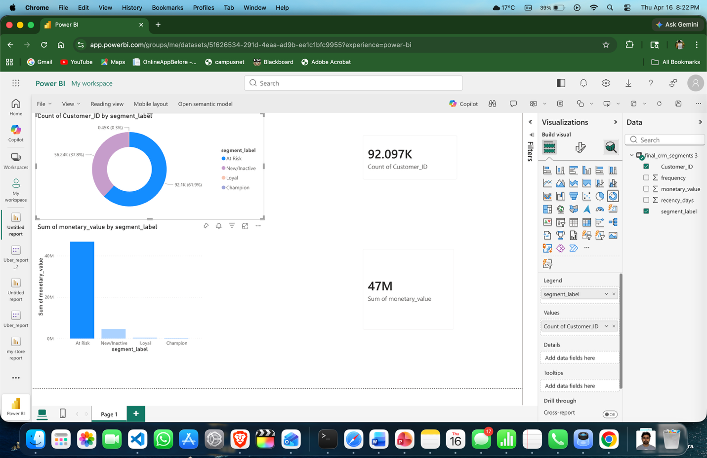
Figure 4: Final Power BI Dashboard showing the 'At-Risk' segment (61.9% of users). The visualization quantifies the $47 million revenue risk, providing a high-priority target list for CRM re-engagement.

8. Contribution of Team Member
- Vamsi Seela: Sole Developer and Lead Architect. Responsible for end-to-end execution, including dataset selection, Python ETL script development, SQL Star Schema design, RFM segmentation logic, and Power BI dashboard creation.

9. References
- Laddha, Y. (2024). Uber Ride Analytics Dashboard. Kaggle. Available at: https://www.kaggle.com/datasets/yashdevladdha/uber-ride-analytics-dashboard
- Uber Engineering. (2025, March). Enhancing Personalized CRM Communication with Contextual Bandit Strategies. Uber Blog. Available at: https://www.uber.com/blog/enhancing-personalized-crm/
- Kimball, R., & Ross, M. (2013). The Data Warehouse Toolkit: The Definitive Guide to Dimensional Modeling. Wiley. (Reference for Star Schema methodology).
- Putler. (2023). RFM Analysis: Segment your customers for better marketing. Available at: https://www.putler.com/rfm-analysis/
- CRM Theory: Putler. (2023). RFM Analysis: Segment your customers for better marketing. https://www.putler.com/rfm-analysis/
- Microsoft Power BI Documentation. Connecting to SQL Databases and Data Modeling Best Practices. (2025).

10. Appendix
- Source Code Repository: [INSERT YOUR GITHUB LINK HERE]
- Primary ETL Script: 01_clean_data.py (Refer to Repo)
- Database Schema: 03_sql/uber_crm.db (Refer to Repo)

